H.T No
Regulations:
A14

Sreenidhi Institute of Science and Technology
(An Autonomous Institution)
Code No:4AC41 Date: 31-Oct-2020 (FN)

B.Tech II-Year I-Semester External Examination, October - 2020 (Supplementary)
BASIC ELECTRICAL ENGINEERING (ME,CSE and IT)

Time: 2 Hours Max.Marks:70

Note: a) No additional answer sheets will be provided.
b) All sub-parts of a question must be answered at one place only, otherwise it will not be valued.
c) Missing data can be assumed suitably.

ANSWER ANY 5 OUT OF 8 QUESTIONS. EACH QUESTION CARRIES 14 MARKS.

1. | a) | Calculate current in the 1Ω resistor in fig.1 using superposition theorem.  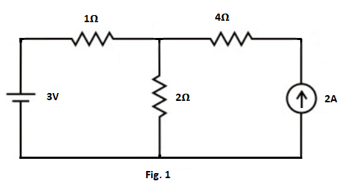 | [7M]
 | b) | State and explain Maximum Power Transfer Theorem with an example. | [7M]
2. | a) | Define the following terms w.r.t AC waveforms.  (i) frequency  (ii) average value  (iii) r.m.s value  (iv)phasor  (v) form factor. | [7M]
 | b) | A coil has a resistance of 5Ω and draws a current of 20A when connected across a 260V, 50 Hz supply. Determine (i) Inductance of the coil (ii) power factor of the circuit (iii) reactive power. Draw the phasor diagram. | [7M]
3. | a) | Derive the expression for torque of a DC motor. | [7M]
 | b) | A DC shunt generator has a full load output of 10 KW at a terminal voltage of 200V. The armature and shunt field winding resistance are 0.1Ω and 200Ω respectively. Stray losses are 800W. Determine the efficiency. | [7M]
4. | a) | Explain the construction and working of a single phase transformer with a neat diagram. | [7M]
 | b) | A 25 KVA , 2500/250 volts, 50Hz single phase transformer gave the following test results  OC Test (LV side) :250V, 4A, 150W  SC Test( HV side) :90V, 10A, 350W  Determine the efficiency and Regulation at full load, 0.8 pf lag. | [7M]
5. | a) | A balanced star connected load of (9+j12) Ω is connected to 3-Phase , 415V supply. Find the line current, power factor active power, reactive power and apparent power. | [7M]
 | b) | An 8- pole induction motor fed from 50 Hz supply runs at 720 rpm.  Determine  (i) Synchronous speed  (ii)slip speed  (iii) per unit slip  (iv) percentage slip  (v) frequency of rotor currents. | [7M]
6. | a) | Explain the various methods of providing Controlling Torque in indicating instruments. List their advantages and disadvantages. | [7M]
 | b) | Explain the working of an MI instrument with a neat diagram. | [7M]
7. | a) | State and Explain Thevenin’s Theorem with an example. | [7M]
 | b) | Derive the expressions for r.m.s value and average values of a sine wave. | [7M]
8. | a) | Derive the expressions for converting a delta network to a star network. | [7M]
 | b) | Explain how the range of a PMMC voltmeter can be extended with an example. | [7M]

-- 00 -- 00 –

